Created by: inkyb , mturkgrind.com

Name: Transfer Earnings Macro

Description: This macro can be used to automatically upload your current earnings from the mTurk dashboard into Amazon payments, and will then withdraw these earnings into your respective bank account.

Sequence of Events

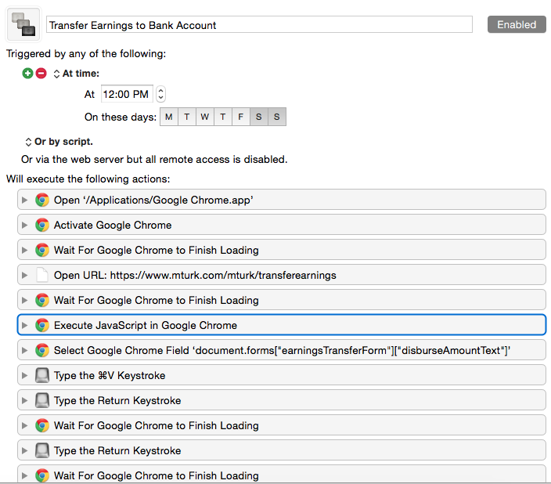

This macro runs at 12:00 PM, Monday – Friday.

The frequency can be changed as much as you’d like.

NOTE: THIS MACRO ASSUMES THAT YOU ARE ALREADY SIGNED INTO THE MTURK DASHBOARD. THIS STEP CAN BE ADDED (manually), OR I CAN REUPLOAD WITH THE PROPER SETUP FOR LOGGING IN.

The first sequences pertain to the number amount that is currently in your

“Earning Available for Transfer”.

The macro will paste this number into the earnings bar and submit so that it will be transferred to your amazon payments account.

Upon completion of the transfer to Amazon Payments, the macro will attempt to sign-in to amazon payments.

For this step, you must first configure your macro for YOUR amazon login:

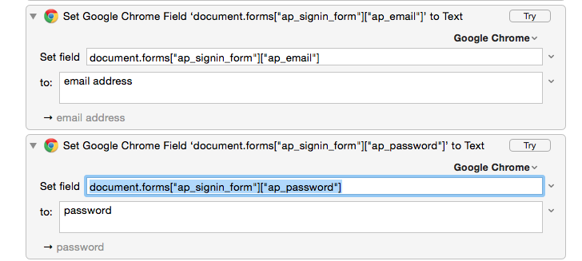

Expand these two sequences within KM, and set the correct values.

The changes will automatically save.

Once that is complete, you will be logged into Amazon Payments and directed to the

“Withdraw Funds” page.

For these next few steps, you must configure the macro in KM for YOUR bank information.

To find this information follow these steps:

Go into “Withdraw Funds” tab in Amazon Payment

Right-click on the drop down menu for Accounts

Click ‘Inspect Element’

This (or something similar) should appear:

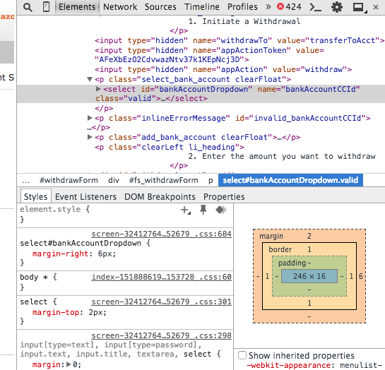

Click the arrow of the highlighted row

This will give you a list of options with corresponding values

Double click within the “value” line and copy the value for your respective bank account

Once this is completed, open KM and open this sequence:

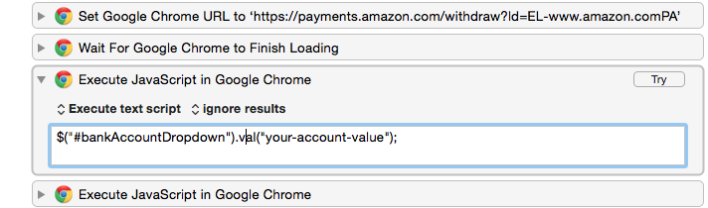

Replace ‘your-account-value’ with the value you just copied from the webpage

Changes will automatically save

That’s all ! You should now be setup to start this macro and have your earnings automatically transferred at your convenience!

Enjoy ☺

-InkyB™

© 2015